In Progress Deliverables 2.0_Nomads Quiz Project
Feedback | Status
Rewrite this eyebrow section to:
For founders and marketing teams reaching 10,000+ visitors a month across their digital channels who want to generate an extra $1.5M/year without increasing marketing spend.
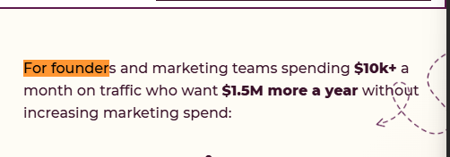
Replace “Score all four quadrants…” sentence with:
Your metrics show *where* you lose revenue. The 4 pillars show *why*. Score them with your team. Lowest score = your first fix.
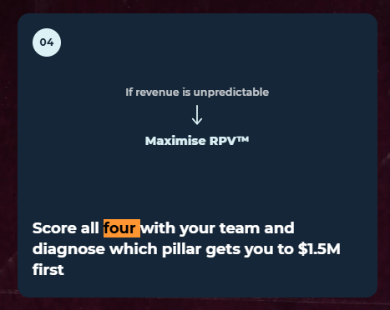
Update text to:
Your first step to stacking $125k/mo($1.5M/year) on top of your current monthly revenue.
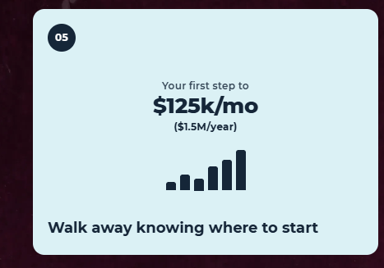
[Speedometer]
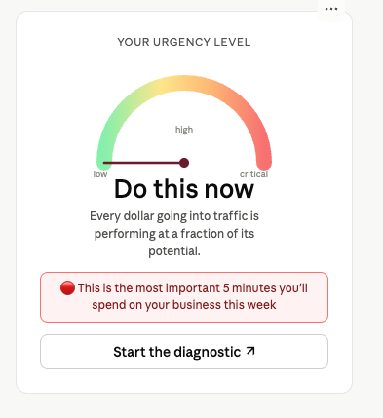
The copy below the first speedometer section is missing.

“You're running cold ads straight to your website or product pages”
Here’s the copy. Also, updated and highlighted in pink on the updated landing page copy doc.
Score: 10

Your urgency level: DO THIS NOW.

Every visitor who leaves without buying is a potential customer gone (and wasted marketing spend).

This is the most important 5 minutes you'll spend on your business this week.

Start the diagnostic →

Update testimonial copy and hierarchy. Copy below and also added in the updated landing page copy doc highlighted in pink.

Here's how Compounding Revenue Per Visitor™ added millions to our clients' businesses

BEFORE | AFTER
An e-commerce business was getting 440K visits, but only 250 demo bookings. At first, that seemed fine, until they realized it added up to just booking 1 freakin demo per 2500 web visitors (0.044% conversion rate). | With all four of our CRPV ™ quantum leap moves in place, Golfbays went on to book one demo per seven quiz takers (14%), and generated £96,000+ in just 12 days on the same ad spend.
A media business launch grossed $70K with a 6% email click-through rate (CTR). The client thought it was a flex until they saw our 45% CTR and hired us for their next launch. | With our Compounding Revenue Per Subscriber™ move, her next launch hit $150K on the same traffic.  We carried the buyer insights and proof into the following launch, which brought in $500K with email click-through rates as high as 40%.
A video mastermind owner tanked 27 discovery calls and closed one client. | We crafted his category-dominating argument (Contrarian POV™) that made him *THE* only option in his industry.  He went on to close 29 of the next 31 calls, taking monthly revenue from $8,000 to $108,000.
An executive coach was getting 2,800 LinkedIn profile views a quarter, but fewer than 500 new subscribers a month and $0 in revenue from emails. | We found the trigger that let her reach a 20× larger market with our Maximize Revenue Per Visitor™ move.  Her Personality Peak™ quiz then brought in 2,100 subscribers in 35 days, generating $1,000/day from her subscription offer.
A course creator made $70K+ from her tiny list (she believed in email potential), but her list was exhausted. | Our Speed to Decision™ move let fresh prospects experience her expertise in under five minutes.  Her list grew by 7,706% in 72 hours, putting her offer in front of 350+ high-intent prospects without spending a dime on ads.

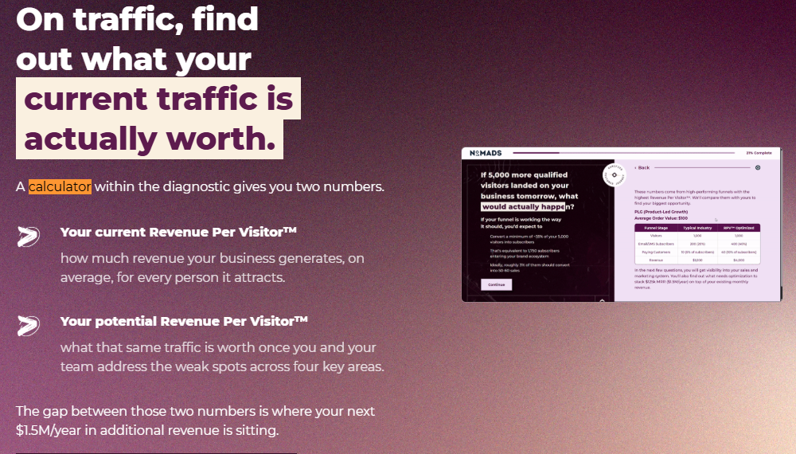
^The GIF here shall focus literally on just the calculator outcome on the results page - the before/after + red/green yellow
In the section - “A private On-Demand workshop with Alefiya.”
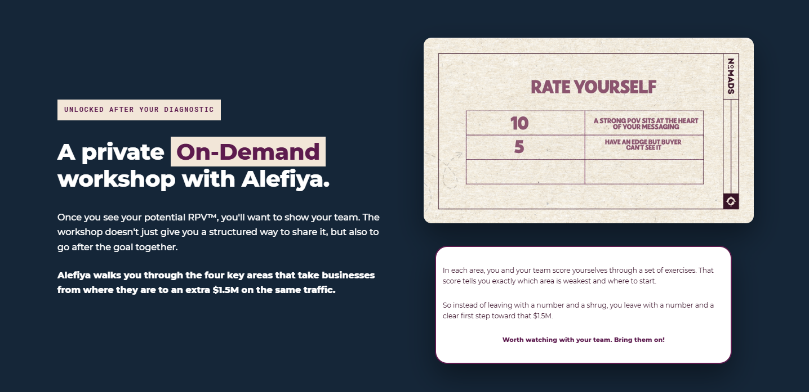
^pls swap the “rate card” visual to the visual we’ve used everywhere - my photo + incomplete diagnostic

Also, replace the copy below it with ⬇️
“In each area, you and your team work through a few exercises to score yourselves. You’ll see exactly where you’re falling short and what to fix first to add $1.5M on top of your last 12 months’ revenue.

Worth watching with your team. Bring them on!”
Once you see your potential Revenue per Visitor™
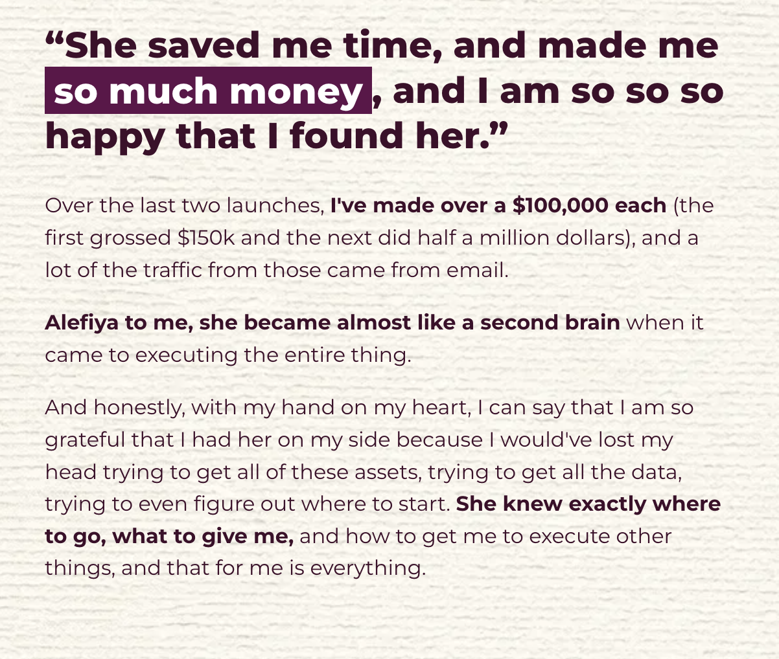
Fix this copy in the last section. Make sure to use the quotation marks:

Become the savvy founder who can confidently say to your team,

“Based on the data, if we optimize “this” metric, we'll add $125k/mo ($1.5M/year).”
Smaller UX issues flagged by Claude:
- Progress bar goes backwards. It drops from 42% to 40% when you select Paid ads, which is Sarah’s complaint.
- Duplicate question numbers. “07” appears three times and “09” twice.
- Highlight boxes cut words mid-word on every slide: “hit 60 s”, “isn’t a fl”, “each eyeb”, “can’t t”, “calcu”.
- The “Keep Scrolling” badge stays on screen. It covers Estelle’s name and the “After” card copy.
- Scroll position carries over. Q13 opens already scrolled down, so the question headline is cut off.
- Estelle’s surname is spelled inconsistently. “Winsett” in the case study, “Winsette” in your docs.
- The Estelle proof screenshot is blurry. It reads “11 were here”, which highlights a tiny sample.
- The final free-text question is required. Friction at 96%. Make it optional.
- The opt-in asks for “Your Email”, not work email. That was Sarah’s suggestion.
- The first landing-page hero CTA click didn’t navigate for me. The header one did. Worth a recheck.

